**Using GitHub**

**Setup:**

1. Create a repo.
2. Clone the repo to your local machine.
3. Create an empty Unity3d project and save it to your repo.
4. Commit and push it to your GitHub account.

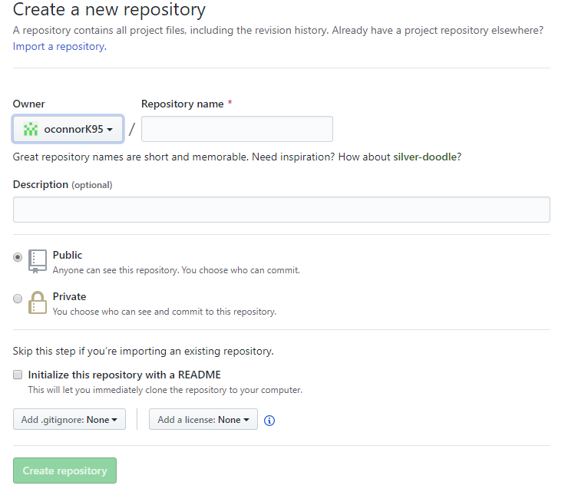

**Collaborators:**

1. To access the repo, collaborators must have links sent to them.
2. After clicking the link, collaborators must fork the repo to copy it to their personal account.

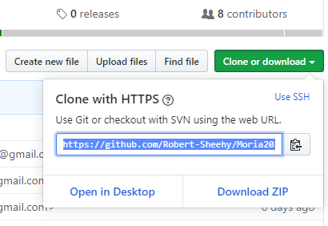

**Local Work:**

1. Clone the project to the local machine.
2. Fetch any changes to the repo so they may be merged with the local repo.

Using Git Bash, type “git remote –v” to see linked remotes.

1. To add the group repo type “<Name><url>
2. Now “git remote –v” should produce 2 repos.
3. Fetch the group repo and merge it to master.
4. Now you can push to origin using Git GUI or Bash.
5. You can work locally and rescan, commit + push to the origin.
6. On your GitHub account, create a pull request to the administrator.

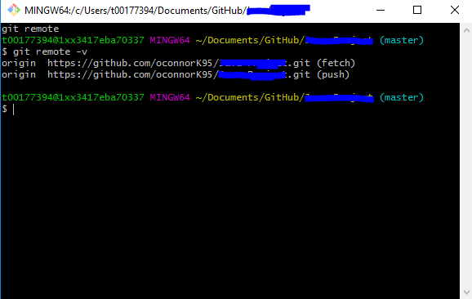

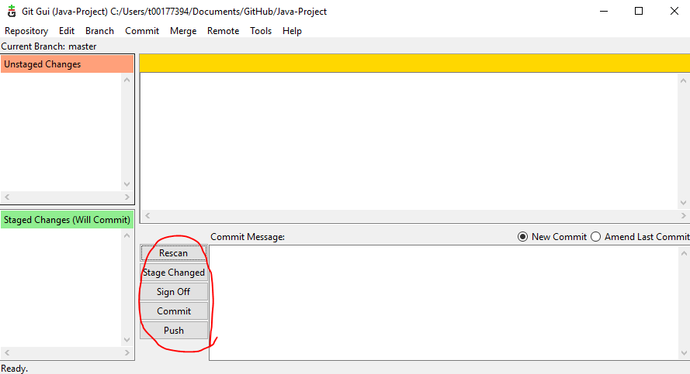

**Administration:**

1. The administrator examines his pull requests.
2. Should the administrator find merge conflicts, they must decide which changes to accept and which to drop. As both pull requests will have conflicting results.
3. The team should be consulted to see if a workaround can be reached and determine which conflicting commit is more valuable.